NázEv SOUTĚžnÍ PRÁCE (Times New Roman, 14pt, tučné písmo)
NázEv SOUTĚžnÍ PRÁCE v ANGLICKÉM JAZYCE (Times New Roman, 14pt, tučné písmo)

Abstrakt (Times New Roman, 11pt)
Text text text text text text text text text text text text text text text text text text text text text text text text text text text text text text text text text text text (maximum 1000 znakov)
Klíčová slova: slovo, slovo, slovo, slovo (3-5 slov)

Abstract (Times New Roman, 11pt)
Text text text text text text text text text text text text text text text text text text text text text text text text text text text text text text text text text text
Key words: word, word, word, word (3-5 words)

Úvod (hlavní názvy, Times New Roman, 12pt, velká písmena, tučné písmo)
Podnadpis 1 (podnadpisy Times New Roman, 12pt, tučné písmo)
Text text text text text text text text text text text text text text text text text text text text text text text text text text text text text text text text text text text text text text text text text text text text text text text text text text text text text text text text text text text text text text text text text text text text text text (Times New Roman, 12pt)
Text text text text text text text text text text text text text text text text text text text text text text text text text text text text text text text text text text text text text text text text text text text text text text text text text text text text text text text text text text
Text text text text text text text text text text text text text text text text text text text text text text text text text text text text text text text text text text text text text text text text text text text text text text text text text text text text text text text text text text text text text text text text text text text text text text
Text text text text text text text text text text text text text text text text text text text text text text text text text text text text text text text text text text text text text text text text text text text text text text text text text text text text text text text text text text
Podnadpis 2
Text text text text text text text text text text text text text text text text text text text text text text text text text text text text text text text text text text text text text text text text text text text text text text text text text text text text text text text text text text text text text text text text text text text text text text

Podnadpis 3
Text text text text text text text text text text text text text text text text text text text text text text text text text text text text text text text text text text text text text text text text text text text text text text text text text text text text text text text text text text text text text text text text text text text text text text

MetOdY
Podnadpis 1
Text text text text text text text text text text text text text text text text text text text text text text text text text text text text text text text text text text text text text text text text text text text text text text text text text text text text text text text text text text text text text text text text text text text text text text
Podnadpis 2
Text text text text text text text text text text text text text text text text text text text text text text text text text text text text text text text text text text text text text text text text text text text text text text text text text text text text text text text text text text

Výsledky
Text text text text text text text text text text text text text text text text text text text text text text text text text text text text text text text text text text text text text text text text text text text text text text text text text text text text text text text text text text text text text text text text text text text text text text text text text text text text text text text text text text text text text text text.
Text text text text text text text text text text text text text text text text text text text text text text text text text text text text text text text text text text text text text text text text text text text text text text text text text text text text text text text text text text text text text text text text text text text text text text text text text text text text text text text text text text text text text text text
Tabulka 4
Distribúcia participantov z hľadiska onkologickej diagnózy
 | Početnosti | Percentá
rakovina prsníka | 73 | 71.6
rakovina hrubého čreva | 8 | 7.8
rakovina lymfatických uzlín | 7 | 6.9
rakovina vaječníkov | 4 | 3.9
leukémia | 2 | 2.0
rakovina prostaty | 2 | 2.0
rakovina močového mechúra | 1 | 1.0
rakovina krčka maternice | 1 | 1.0
iné | 4 | 3.9
spolu | 102 | 100.0

Graf 1
Skladba výskumného súboru z hľadiska veku
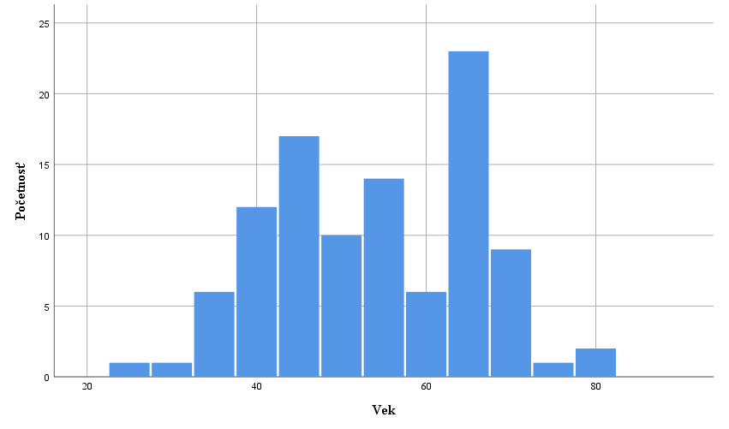

Text text text text text text text text text text text text text text text text text text text text text text text text text text text text text text text text text text text text text text text text text text text text text text text text text text text text text text text text text text text text text text text text text text text text text text text text text text text text text text text text text text text text text text text text text text text text text text text text

DISKUSE
Text text text text text text text text text text text text text text text text text text text text text text text text text text text text text text text.
Text text text text text text text text text text text text text text text text text text text text text text text text text text text text text text text text text text text text text text text text text text text text text text text text text text text text text text text text text text text text text text

LITERATURA (hlavné názvy, Times New Roman, 12pt, veľké písmená, tučné písmo, norma APA7)
- Záznam zdroja podľa APA7 (Times New Roman, 12pt)
- Záznam zdroja podľa APA7
- Záznam zdroja podľa APA7

Příklady nejčastějších záznamů zdrojů uvedených v literatuře podle APA7
Kniha
Emmons, R. A. (2007). THANKS! How the New Science of Gratitude Can Make You Happier (1st ed.). Howghton Mifflin Company.

Kapitola v kolektivní monografii alebo příspěvek v sborníku
Schaefer, J. A., & Moos, R. H. (1998). The Context for Posttraumatic Growth: Life Crises, Individual and Social Resources, and Coping. In R. G. Tedeschi, C. L. Park, & L. G. Calhoun (Eds.), Posttraumatic Growth: Positive Changes in the Aftermath of Crisis (1st ed., pp. 99-126). Lawrence Erlbaum Associates.

Článek v časopise
Rickards, T., & Jones, L. J. (1991). Towards the identification of situational barriers to creative behaviors: The development of a self-report inventory. Creativity Research Journal, 4(4), 303-315. https://doi.org/10.1080/10400419109534408

Termín odeslaní soutěžní práce do 04.03.2024
Maximální rozsah příspěvku je 15 normostran (včetně literatury, bez příloh)
Příspevky zasílejte elektronicky na adresu mfiala@unyp.cz

