**NázEv SOUTĚžnÍ PRÁCE** (Times New Roman, 14pt, tučné písmo)

**NázEv SOUTĚžnÍ PRÁCE v ANGLICKÉM JAZYCE**(Times New Roman, 14pt, tučné písmo)

**Abstrakt** (Times New Roman, 11pt)

Text text text text text text text text text text text text text text text text text text text text text text text text text text text text text text text text text text text (maximum 1000 znaků)

**Klíčová slova:** slovo, slovo, slovo, slovo (3-5 slov)

**Abstract** (Times New Roman, 11pt)

Text text text text text text text text text text text text text text text text text text text text text text text text text text text text text text text text text text

**Key words:** word, word, word, word (3-5 words)

**Úvod** (hlavní názvy, Times New Roman, 12pt, velká písmena, tučné písmo)

**Podnadpis 1** (podnadpisy Times New Roman, 12pt, tučné písmo)

Text text text text text text text text text text text text text text text text text text text text text text text text text text text text text text text text text text text text text text text text text text text text text text text text text text text text text text text text text text text text text text text text text text text text text text (Times New Roman, 12pt)

Text text text text text text text text text text text text text text text text text text text text text text text text text text text text text text text text text text text text text text text text text text text text text text text text text text text text text text text text text text

Text text text text text text text text text text text text text text text text text text text text text text text text text text text text text text text text text text text text text text text text text text text text text text text text text text text text text text text text text text text text text text text text text text text text text text

Text text text text text text text text text text text text text text text text text text text text text text text text text text text text text text text text text text text text text text text text text text text text text text text text text text text text text text text text text text

**Podnadpis 2**

Text text text text text text text text text text text text text text text text text text text text text text text text text text text text text text text text text text text text text text text text text text text text text text text text text text text text text text text text text text text text text text text text text text text text text text

**Podnadpis 3**

Text text text text text text text text text text text text text text text text text text text text text text text text text text text text text text text text text text text text text text text text text text text text text text text text text text text text text text text text text text text text text text text text text text text text text text

**MetOdY**

**Podnadpis 1**

Text text text text text text text text text text text text text text text text text text text text text text text text text text text text text text text text text text text text text text text text text text text text text text text text text text text text text text text text text text text text text text text text text text text text text text

**Podnadpis 2**

Text text text text text text text text text text text text text text text text text text text text text text text text text text text text text text text text text text text text text text text text text text text text text text text text text text text text text text text text text text

**Výsledky**

Text text text text text text text text text text text text text text text text text text text text text text text text text text text text text text text text text text text text text text text text text text text text text text text text text text text text text text text text text text text text text text text text text text text text text text text text text text text text text text text text text text text text text text text.

Text text text text text text text text text text text text text text text text text text text text text text text text text text text text text text text text text text text text text text text text text text text text text text text text text text text text text text text text text text text text text text text text text text text text text text text text text text text text text text text text text text text text text text text

**Tabulka 4**

*Distribuce účastníků výzkumu podle onkologické diagnózy*

|  |  |  |
| --- | --- | --- |
|  | Početnosti | Procenta |
| rakovina prsníku | 73 | 71.6 |
| rakovina tlustého střeva | 8 | 7.8 |
| rakovina lymfatických uzlin | 7 | 6.9 |
| rakovina vaječníků | 4 | 3.9 |
| leukémie | 2 | 2.0 |
| rakovina prostaty | 2 | 2.0 |
| rakovina močového měchýře | 1 | 1.0 |
| rakovina děložního čípku | 1 | 1.0 |
| jiné | 4 | 3.9 |
| spolu | 102 | 100.0 |

**Graf 1**

*Skladba výzkumného souboru z hlediska věku*

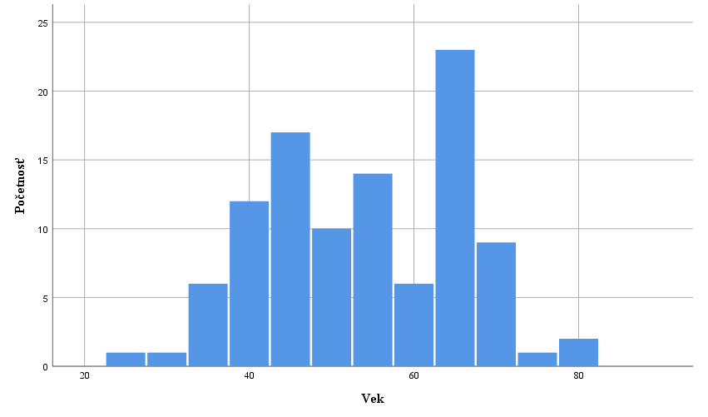

Text text text text text text text text text text text text text text text text text text text text text text text text text text text text text text text text text text text text text text text text text text text text text text text text text text text text text text text text text text text text text text text text text text text text text text text text text text text text text text text text text text text text text text text text text text text text text text text text

**DISKUSE**

Text text text text text text text text text text text text text text text text text text text text text text text text text text text text text text text.

Text text text text text text text text text text text text text text text text text text text text text text text text text text text text text text text text text text text text text text text text text text text text text text text text text text text text text text text text text text text text text text

**LITERATURA** (hlavní názvy, Times New Roman, 12pt, velká písmena, tučné písmo, norma APA7)

1. Záznam zdroje podle APA7 (Times New Roman, 12pt)
2. Záznam zdroje podle APA7 (Times New Roman, 12pt)
3. Záznam zdroje podle APA7 (Times New Roman, 12pt)

**Příklady nejčastějších záznamů zdrojů uvedených v literatuře podle APA7**

**Kniha**

Emmons, R. A. (2007). *THANKS! How the New Science of Gratitude Can Make You Happier* (1st ed.)*.* Howghton Mifflin Company.

**Kapitola v kolektivní monografii alebo příspěvek v sborníku**

Schaefer, J. A., & Moos, R. H. (1998). The Context for Posttraumatic Growth: Life Crises, Individual and Social Resources, and Coping. In R. G. Tedeschi, C. L. Park, & L. G. Calhoun (Eds.), *Posttraumatic Growth: Positive Changes in the Aftermath of Crisis* (1st ed., pp. 99-126). Lawrence Erlbaum Associates.

**Článek v časopise**

Rickards, T., & Jones, L. J. (1991). Towards the identification of situational barriers to creative behaviors: The development of a self-report inventory. *Creativity Research Journal, 4*(4), 303-315. <https://doi.org/10.1080/10400419109534408>