**TITLE Of the competition work** (Times New Roman, 14pt, Bold)

**Abstract** (Times New Roman, 11pt)

Text text text text text text text text text text text text text text text text text text text text text text text text text text text text text text text text text text

**Key words:** word, word, word, word (3-5 words)

**INTRODUCTION** (main headings, Times New Roman, 12pt, capital letters, Bold)

**Subheading 1** (subheadings Times New Roman, 12pt, Bold)

Text text text text text text text text text text text text text text text text text text text text text text text text text text text text text text text text text text text text text text text text text text text text text text text text text text text text text text text text text text text text text text text text text text text text text text (Times New Roman, 12pt)

Text text text text text text text text text text text text text text text text text text text text text text text text text text text text text text text text text text text text text text text text text text text text text text text text text text text text text text text text text text

Text text text text text text text text text text text text text text text text text text text text text text text text text text text text text text text text text text text text text text text text text text text text text text text text text text text text text text text text text text text text text text text text text text text text text text

Text text text text text text text text text text text text text text text text text text text text text text text text text text text text text text text text text text text text text text text text text text text text text text text text text text text text text text text text text text

**Subheading 2**

Text text text text text text text text text text text text text text text text text text text text text text text text text text text text text text text text text text text text text text text text text text text text text text text text text text text text text text text text text text text text text text text text text text text text text text

**Subheading 3**

Text text text text text text text text text text text text text text text text text text text text text text text text text text text text text text text text text text text text text text text text text text text text text text text text text text text text text text text text text text text text text text text text text text text text text text

**METHOD**

**Subheading 1**

Text text text text text text text text text text text text text text text text text text text text text text text text text text text text text text text text text text text text text text text text text text text text text text text text text text text text text text text text text text text text text text text text text text text text text text

**Subheading 2**

Text text text text text text text text text text text text text text text text text text text text text text text text text text text text text text text text text text text text text text text text text text text text text text text text text text text text text text text text text text

**RESULTS**

Text text text text text text text text text text text text text text text text text text text text text text text text text text text text text text text text text text text text text text text text text text text text text text text text text text text text text text text text text text text text text text text text text text text text text text text text text text text text text text text text text text text text text text text.

Text text text text text text text text text text text text text text text text text text text text text text text text text text text text text text text text text text text text text text text text text text text text text text text text text text text text text text text text text text text text text text text text text text text text text text text text text text text text text text text text text text text text text text text

**Table 4**

*Distribution of participants in terms of cancer diagnosis*

|  |  |  |
| --- | --- | --- |
|  | N | Percentage |
| breast cancer | 73 | 71.6 |
| colon cancer | 8 | 7.8 |
| cancer of the lymph nodes | 7 | 6.9 |
| ovarian cancer | 4 | 3.9 |
| leukaemia | 2 | 2.0 |
| prostate cancer | 2 | 2.0 |
| bladder cancer | 1 | 1.0 |
| cervical cancer | 1 | 1.0 |
| other | 4 | 3.9 |
| Total | 102 | 100.0 |

**Graph 1**

*Distribution of the sample in terms of age*

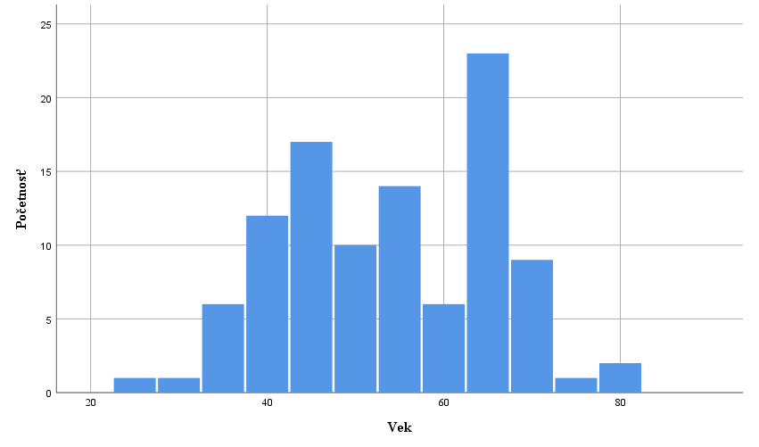

Text text text text text text text text text text text text text text text text text text text text text text text text text text text text text text text text text text text text text text text text text text text text text text text text text text text text text text text text text text text text text text text text text text text text text text text text text text text text text text text text text text text text text text text text text text text text text text text text

**DISCUSSION**

Text text text text text text text text text text text text text text text text text text text text text text text text text text text text text text text.

Text text text text text text text text text text text text text text text text text text text text text text text text text text text text text text text text text text text text text text text text text text text text text text text text text text text text text text text text text text text text text text

**REFERENCES** (headings, Times New Roman, 12pt, capital letters, Bold, Standard APA7)

1. Reference according to APA7 (Times New Roman, 12pt)
2. Reference according to APA7
3. Reference according to APA7

**Examples of the most common source references according to APA7**

**Book**

Emmons, R. A. (2007). *THANKS! How the New Science of Gratitude Can Make You Happier* (1st ed.)*.* Howghton Mifflin Company.

**Chapter in the edited book or proceedings**

Schaefer, J. A., & Moos, R. H. (1998). The Context for Posttraumatic Growth: Life Crises, Individual and Social Resources, and Coping. In R. G. Tedeschi, C. L. Park, & L. G. Calhoun (Eds.), *Posttraumatic Growth: Positive Changes in the Aftermath of Crisis* (1st ed., pp. 99-126). Lawrence Erlbaum Associates.

**Journal article**

Rickards, T., & Jones, L. J. (1991). Towards the identification of situational barriers to creative behaviours: The development of a self-report inventory. *Creativity Research Journal, 4*(4), 303-315. <https://doi.org/10.1080/10400419109534408>