NÁZOV SúŤažnej práce (Times New Roman, 14pt, tučné písmo)
NÁZOV SúŤažnej práce v anglickom jazyku (Times New Roman, 14pt, tučné písmo)

Abstrakt (Times New Roman, 11pt)
Text text text text text text text text text text text text text text text text text text text text text text text text text text text text text text text text text text text (maximum 1000 znakov)
Kľúčové slová: slovo, slovo, slovo, slovo (3-5 slov)

Abstract (Times New Roman, 11pt)
Text text text text text text text text text text text text text text text text text text text text text text text text text text text text text text text text text text
Key words: word, word, word, word (3-5 words)

Úvod (hlavné názvy, Times New Roman, 12pt, veľké písmená, tučné písmo)
Podnadpis 1 (podnadpisy Times New Roman, 12pt, tučné písmo)
Text text text text text text text text text text text text text text text text text text text text text text text text text text text text text text text text text text text text text text text text text text text text text text text text text text text text text text text text text text text text text text text text text text text text text text (Times New Roman, 12pt)
Text text text text text text text text text text text text text text text text text text text text text text text text text text text text text text text text text text text text text text text text text text text text text text text text text text text text text text text text text text
Text text text text text text text text text text text text text text text text text text text text text text text text text text text text text text text text text text text text text text text text text text text text text text text text text text text text text text text text text text text text text text text text text text text text text text
Text text text text text text text text text text text text text text text text text text text text text text text text text text text text text text text text text text text text text text text text text text text text text text text text text text text text text text text text text text
Podnadpis 2
Text text text text text text text text text text text text text text text text text text text text text text text text text text text text text text text text text text text text text text text text text text text text text text text text text text text text text text text text text text text text text text text text text text text text text text

Podnadpis 3
Text text text text text text text text text text text text text text text text text text text text text text text text text text text text text text text text text text text text text text text text text text text text text text text text text text text text text text text text text text text text text text text text text text text text text text

MetódY
Podnadpis 1
Text text text text text text text text text text text text text text text text text text text text text text text text text text text text text text text text text text text text text text text text text text text text text text text text text text text text text text text text text text text text text text text text text text text text text text
Podnadpis 2
Text text text text text text text text text text text text text text text text text text text text text text text text text text text text text text text text text text text text text text text text text text text text text text text text text text text text text text text text text text

Výsledky
Text text text text text text text text text text text text text text text text text text text text text text text text text text text text text text text text text text text text text text text text text text text text text text text text text text text text text text text text text text text text text text text text text text text text text text text text text text text text text text text text text text text text text text text.
Text text text text text text text text text text text text text text text text text text text text text text text text text text text text text text text text text text text text text text text text text text text text text text text text text text text text text text text text text text text text text text text text text text text text text text text text text text text text text text text text text text text text text text text
Tabuľka 4
Distribúcia participantov z hľadiska onkologickej diagnózy
 | Početnosti | Percentá
rakovina prsníka | 73 | 71.6
rakovina hrubého čreva | 8 | 7.8
rakovina lymfatických uzlín | 7 | 6.9
rakovina vaječníkov | 4 | 3.9
leukémia | 2 | 2.0
rakovina prostaty | 2 | 2.0
rakovina močového mechúra | 1 | 1.0
rakovina krčka maternice | 1 | 1.0
iné | 4 | 3.9
spolu | 102 | 100.0

Graf 1
Skladba výskumného súboru z hľadiska veku
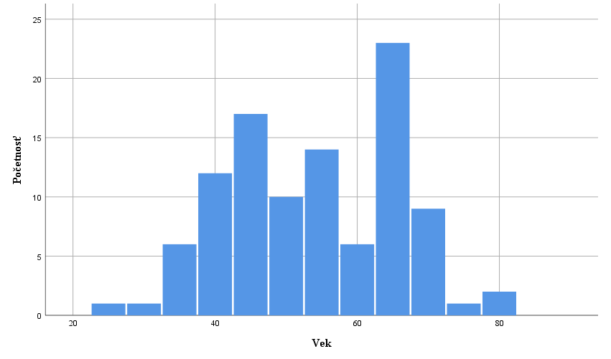

Text text text text text text text text text text text text text text text text text text text text text text text text text text text text text text text text text text text text text text text text text text text text text text text text text text text text text text text text text text text text text text text text text text text text text text text text text text text text text text text text text text text text text text text text text text text text text text text text

DISKUSIA
Text text text text text text text text text text text text text text text text text text text text text text text text text text text text text text text.
Text text text text text text text text text text text text text text text text text text text text text text text text text text text text text text text text text text text text text text text text text text text text text text text text text text text text text text text text text text text text text text

LITERATÚRA (hlavné názvy, Times New Roman, 12pt, veľké písmená, tučné písmo, norma APA7)
- Záznam zdroja podľa APA7 (Times New Roman, 12pt)
- Záznam zdroja podľa APA7
- Záznam zdroja podľa APA7

Príklady najčastejších záznamov zdrojov uvedených v literatúre podľa APA7
Kniha
Emmons, R. A. (2007). THANKS! How the New Science of Gratitude Can Make You Happier (1st ed.). Howghton Mifflin Company.

Kapitola v kolektívnej monografii alebo príspevok v zborníku
Schaefer, J. A., & Moos, R. H. (1998). The Context for Posttraumatic Growth: Life Crises, Individual and Social Resources, and Coping. In R. G. Tedeschi, C. L. Park, & L. G. Calhoun (Eds.), Posttraumatic Growth: Positive Changes in the Aftermath of Crisis (1st ed., pp. 99-126). Lawrence Erlbaum Associates.

Článok v časopise
Rickards, T., & Jones, L. J. (1991). Towards the identification of situational barriers to creative behaviors: The development of a self-report inventory. Creativity Research Journal, 4(4), 303-315. https://doi.org/10.1080/10400419109534408

